

One thing I love about Soroptimist is that we believe we have the power to change outcomes. No one's life is set.

Do you realize that last night we were yelling at a pre-recorded horse race with an already decided winner. We believed our cheering - our encouragement - would change the results. We believe that we can and do change outcomes by our actions every day.

Now I will tell you that looking out onto this room full of accomplished women, I realize that inspiring women are inspiring because they have a positive attitude.

You are women who choose to be happy, choose to see the bright side of life, choose to be optimistic, choose to smile, choose to have faith, choose to spend time with happy people, choose to inspire others.

Just like our inspiring women in this room, our organization is inspiring - because we have a positive focus.



Just look at our major projects:

* We dream it and we offer resources to become it.
* We believe in living our dreams and we give the resources to others so they will live their dreams.
* We believe in our mission – to improve lives.

Everything we do…every member…every club…every inspiring woman, has chosen to lay the foundation for a positive future for women and girls throughout the world.

That really is it. The umbrella that covers everything that inspires us - is choosing a positive message, a positive attitude – a reset of your mind, if need be, to be positive.

Now some of our clubs are struggling - we've lost four clubs this year. But some of our clubs are thriving - we've gained over 130 members in our region. What is the difference? Why are some losing members and others are increasing?

Maybe we'll find out. We’ve asked four inspiring presidents from four inspiring clubs to talk with us about what makes their club inspiring – they’ll be speaking with you in a moment.

Maybe it’s merely being passionate about our mission – maybe it just being positive about their abilities. Maybe they are focused and visualize success. Maybe they support each other no matter what.

Maybe it’s reminding their members of how inspiring they are and what they have accomplished. Positive affirmation every meeting – every day. Maybe if we snuck into their homes or their meetings - this is them… Let's watch this young lady as our own inspiration for positive reinforcement.

<https://www.youtube.com/watch?v=SQIVslZIMXI> (I like my…50 seconds)

“I can do anything good. Yeah Yeah Yeah. Better. Better than anyone. Better than anyone." Don't you just want to hug those who encourage her to be grateful?



Speaking of positive reinforcement and gratitude…did I thank you for being here enough? Sincerely. Thank you for taking time out of your busy life to come to Riverside this weekend – to share your time, your talent, your money, your energy with us. We are here this weekend to celebrate you – and some of the recipients of your great work - and the work of our organization. Think about it - we provide positive inspiration that allows women throughout the world to blossom. We are here to learn and to celebrate you. I truly thank you for what you do and for being here.

What inspires us - is as varied as the lives we live. Inspiration is that tug at your heart and your mind, when you are moved to action - or reaction - by something you’re passionate about.

SLIDE:

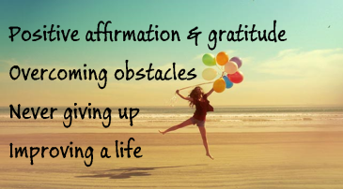

What’s inspiring to us? Four things:

1. Positive affirmation and gratitude
2. Overcoming obstacles
3. Never giving up
4. Improving a life

Given our commitment to Soroptimist to help others and our reactions during the Live Your Dream Awards - no dry eye in the crowd - What’s inspiring to us? Four things:

* Positive affirmation and gratitude
* People who overcome obstacles
* People who never give up
* People who improve their own lives and the lives of others

Overcoming obstacles with a positive attitude and gratitude.

We all have women in our lives who are inspiring for different reasons. Sometimes we don’t personally know them - like our LYDA recipients we just meet here at Spring Conference. I want to share a little about someone who overcomes obstacles ... [insert personal story here.]

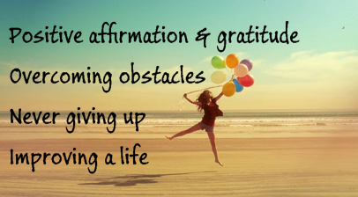

We are inspired by people who overcome obstacles and maintain a positive attitude and gratitude. [insert personal story here.]

We are inspired by people who never give up and maintain a positive attitude and gratitude. [insert personal story here.]

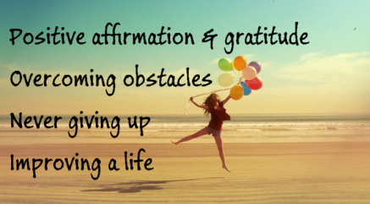

These women overcame obstacles and never gave up.

We are inspired by people who improve their lives or the life of another while maintaining a positive attitude and gratitude. We do this every day. We should all work on our own positive attitude. When it comes to our clubs, let's look at what we do - my goodness!

SLIDE:

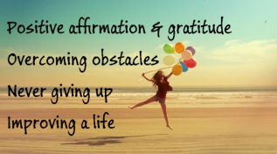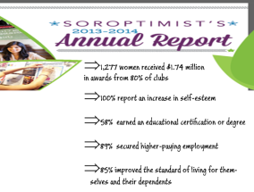

These numbers were presented earlier by Liz Lucas and can be found on the soroptimist website in our annual report. In FY13/14, SIA disbursed $1.74 million (a 7 percent increase) to 1,277 deserving women (a 3 percent increase) in awards,

* with 80 percent of Soroptimist clubs (a 6 percent increase) delivering this life-changing program around the world.

Of those surveyed, 100 percent of recipients report an increase in self-esteem; 58 percent earned an educational certification or degree; 89 percent of those who completed their education secured higher-paying employment; 85 percent improved the standard of living for themselves and their dependents; and 94 percent are serving as a role model for their dependents.

This is why we are soroptimists. This is why we are inspired. Women overcoming obstacles, never giving up, improving their own lives, with positive changes and positive attitudes.

SLIDE:

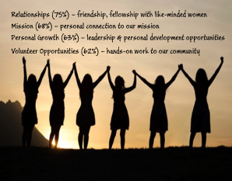

A few years ago at our Leadership Training Retreat, we asked you to write down on a post-it why you joined our organization and another post-it for why you stay. The results of that little exercise were the same as a survey conducted by our Federation. We join and stay with this organization because, we:

* Relationships (75%) – seek friendship and fellowship and being with other like-minded women
* Mission (68%) – express their personal connection to our mission of improving lives
* Personal Growth (63%) – gain leadership and personal development opportunities
* Volunteer Opportunities (62%) – provide hands-on work to our community

And I will add one – we want to be inspired and be an inspiration to others. We want to have and project a positive attitude. We want to be part of a positive organization and a positive club.

We have to do our part. If you are not providing these needs to your members, then you are frankly not doing your part.

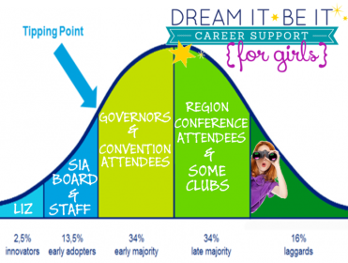

The adoption of innovation curve is a study that says less than 14% a group can turn that group around. Let’s say our Executive Director Liz Lucas came up with a crazy idea of creating a education program targeting teen girls. The first column - she is an innovator. She explains it to her staff, President Poco and the SIA Board. They agree that it’s a great idea and set about floating the idea. These are the Early Adopters and they come up with the name Dream It Be It.

The critical point of turnaround is at this point. Either it catches fire with the passion of this small group, or it goes away with the disappointment of this innovative group.

Liz and the SIA leaders start talking about it with the Governors and during federation meetings, and others start jumping on board – these are the early majority. The Governors and those attending the meetings come back to the regions and provide the materials and conversations to the region members. More jump on board – the late majority. The last remaining “conscientious rejecters” are standing back observing the results but clearly interested in the concept – if it works.

Liz created a shift in the organization by having an innovative idea and presenting it to a small group of our organization. It’s still a new concept but I can tell you that 68% of the Golden West Region – that’s 34 clubs - implemented some or all of Dream It Be It in our programs this year!

So, the average number of members in each of our Golden West Region clubs is 25. So 14% of 25 is how many? Help…help… Less than 4 members.

Let’s get positively radical for a moment. Of course, I mean radical in a positive way!

Think about how many members are in your club. Now do the math. How many members make up 14% of your club? Say it out loud!

My club has [insert number here] members. We need less than [insert number here] members to turn our club around! Just [insert number here]members to get behind a plan to organize – to set meaningful goals and achieve them.

We are not victims. We don’t belong to negative clubs. We are innovators or early adopters who wants to make a positive change. We can take home ideas from this Spring Conference and make a positive shift in our clubs. Now that’s inspiring!

I found an article by a gentleman named Chris Talambas (on Lifehack.com) who identified simple steps to develop a positive attitude: Just these down on the back of your gratitude sheet:

* Laugh more – especially at yourself
  + 
* Help others
  + Well, I think that’s clearly what we do.

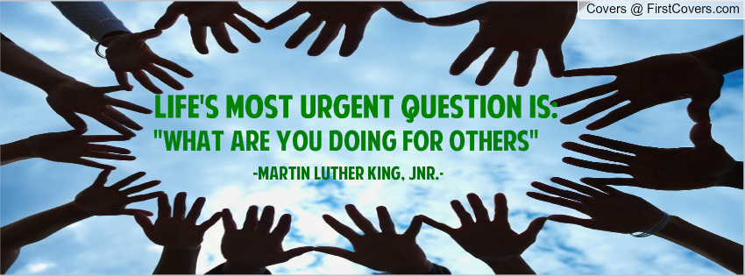

* Change your thinking
  + Do some personal work. Identify and understand who you are and how you come across. Do the same for you club. Make a conscious effort to change your attitude to a positive one. Every member has something positive to offer. Find it. Celebrate it. You'll see a change!



* Look for a role model to help you - well, around here, that’s easy to do.

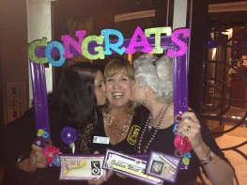

* Believe you can make the change and visualize how a positive attitude will change your life and your club. In her installation speech, President Poco said – if you build it, they will come. If your club is an optimistic place to be – members will stay and members will come.



* Surround yourself with positive people.



* Take positive action – be the radical 4%. 
* Take full responsibility – stop being a victim. Your club can change if you want it to.Your club – positive or negative - is the way it is because of all the members. Take responsibility and make changes.

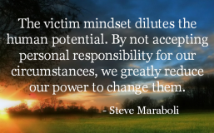

* Become grateful – for everything



Let’s start this right now…on your table is a “gratitude” sheet. You can use it however you’d like.



You can sit there right now and find today’s date – the sixth – and write something that you are grateful for today. Then do the same the next day and the next day. When you see a month’s worth of gratitude, your life will be changed. Your mind will be changed. I promise you it will.

You can also use it on your loved ones as a science project. Put it on your refrigerator and every day post a new thing you are grateful for about your loved ones – your family will read it and they will be changed. Wouldn't your relationships be changed if you posted every day why your loved ones are loved? How would you feel about reading positive comments about yourself everyday?

But I also want you to relate this to our organization – your club. So one of you at each table, volunteer to start the list. For just a couple of minutes, throw out ideas of why you are grateful to be part of this wonderful organization. Ready – go.

Hang on to these and we will be sharing them shortly. Please do this with your own club and celebrate the results.

So what are we doing right and what are we doing wrong? I would like all the members from the following clubs to stand: Kingman, Corona, Lake Havasu City, Riverside, San Jacinto-Hemet Valley, Idyllwild, Desert Cities of the Coachella Valley, and Rim of the World.

These members are getting it right! Each of these clubs increased their membership by at least six new members this year. Take a look at them – during the breaks track them down and ask them what they do. Share stories of you clubs and work out a solution using these great resources.

I also promised that you’d hear from four inspiring clubs. I asked the District Directors to identify a club from each of their districts who they feel are an inspiring club. Of course, they were mad - it’s a hard choice - but they selected: SI San Tans, SI Lake Havasu City, SI Riverside, and SI Moreno Valley.

**INSPIRING CLUBS**

* **Lynn Scecina – president of SI Riverside**
* **Ruth Salley – president of SI Moreno Valley**
* **Carmen Hogard – president of SI Lake Havasu City**
* **Brenda Brown – president of SI San Tans**

The secret to being an inspiring club [notes taken from presentation]:

Lynn Scecina – president of SI Riverside - set goals such as increase membership by 25%. Delegate to others. Involve members. Create fun meetings. Listen to other clubs and use ideas that work for your club.

Ruth Salley – president of SI Moreno Valley - change focus to the Soroptimist mission. Participate in Soroptimist programs and say OK to success. Care and love your members and communicate with them. Recap the meeting for those not able to attend. Adjust meetings to the members' needs.

Carmen Hogard – president of SI Lake Havasu City - Theme is the share the Soroptimist gift with others through fun events. Set goals and support members. Add one element to every project to keep improving and growing. Adjust meetings to meet member needs and build their skills.

Brenda Brown – president of SI San Tans - planning and goals. Select great committee chairs by matching strength with strength. Communicate. Keep lighthearted. No "butts" - replace it with "yes, but." Research how to run meetings and how to handle conflict. Celebrate accomplishments and nurture members. Create a positive club personality.

Friendship, meaningful projects, leadership opportunities, and hands-on work. These clubs have sparked the passion – the optimism – the positive environment to create an inspiring club.

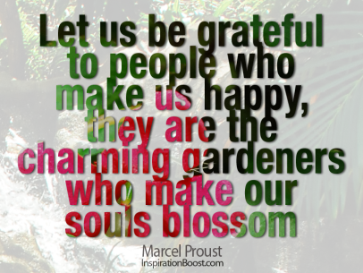

Since we have a few minutes, I’d like to close with this…someone from each table, come forward and read one or two of the comments you wrote on the “Grateful journal.”

How can you not share this experience with others? I’ll end with this challenge…if every member invited one person to join the Soroptimist organization – think how even more inspiring our clubs and our accomplishments will be next year!

